SIMATS ENGINEERING (SAVEETHA SCHOOL OF ENGINEERING)
Department of Computer Science and Engineering
CO2 ASSESSMENT TOOL 1 – Scenario-Based Requirement Analysis

Course Code: | CSA10 / CSA1004 | Course Title: | Software Engineering
CO Assessed: | CO2 | Assessment: | Assessment Tool 2 – Scenario-Based Requirement Analysis
Weightage: | 20% | Total Marks: | 25
CO2 Statement: | Perform detailed requirements analysis, design scalable architectures, and prioritize features with a focus on cross-disciplinary skills
Student Name: | K Sreelatha | Reg. No.: | 192425248
Date: | 27.10.26 | Duration: | 60 minutes

Code of Conduct
I __K Sreelatha(192425248)__ (Name / Reg No) certify that this submission is my original work and that I have adhered to the guidelines specified for this assessment. I understand that any violation of academic integrity rules will result in disciplinary action.
Signature of the Student: __Sree K______
Annexure A – Scenario-Based Requirement Analysis
Instructions to Students:
Each student will be assigned an individual software project problem statement. Analyze the given scenario and prepare a complete Software Requirement Analysis document by following the steps below.

Question
Based on the assigned problem statement, perform a Scenario-Based Requirement Analysis and prepare a Software Requirement Specification (SRS) document. Your analysis should include the following:
- Study and Analyze the Scenario
  - Carefully understand the given problem statement.
  - Identify the business domain, stakeholders, existing challenges, and system objectives.
- Identify Functional and Non-Functional Requirements
  - List all functional requirements required by the proposed system.
  - Identify suitable non-functional requirements such as performance, security, reliability, usability, scalability, maintainability, and availability.
- Identify Actors and Use Cases
  - Identify all primary and secondary actors interacting with the system.
  - List the major use cases associated with each actor.
  - Draw a Use Case Diagram representing the interactions between actors and the system.
- Prepare the Software Requirement Specification (SRS)
Develop an SRS document containing:
  - Introduction
  - Problem Description
  - Scope of the System
  - Functional Requirements
  - Non-Functional Requirements
  - Use Case Descriptions
  - Data Requirements
  - External Interface Requirements
  - System Features
- Identify Assumptions and Constraints
  - List the assumptions considered while developing the system.
  - Identify technical, operational, economic, legal, and time-related constraints affecting the project.
- Validate Requirement Completeness and Consistency
  - Verify whether all stakeholder requirements have been addressed.
  - Check for ambiguity, redundancy, inconsistency, and missing requirements.
  - Suggest improvements to enhance the quality and completeness of the requirement specification.

Project: Intelligent Public Transport Monitoring System
1. Study and Analyze the Scenario
1.1 Introduction to the Problem
The Intelligent Public Transport Monitoring System is a software-based system designed to improve public transportation by providing real-time bus tracking, estimated arrival times, route information, and passenger occupancy details.
In the existing approach, passengers may not know the exact location of a bus or its expected arrival time. Transport administrators may also experience difficulties monitoring multiple buses, managing schedules, and identifying delays.
The proposed system uses GPS and data-processing technologies to collect bus location information, estimate arrival times, and display useful information to passengers and transport administrators.
1.2 Business Domain
The business domain is Public Transportation and Transport Management.
The system focuses on improving bus operations, passenger information services, route management, and transport monitoring.
1.3 Stakeholders
Stakeholder | Role
Passengers | View bus locations, arrival times, routes, and occupancy information.
Bus Drivers | Operate buses and provide trip-related information.
Transport Administrators | Monitor buses, routes, schedules, and delays.
Transport Authorities | Analyze operational performance and improve services.
System Developers | Design, develop, and test the system.
System Administrators | Manage the system, database, and access permissions.
GPS/Data Providers | Provide location and related transport data.
Maintenance Team | Resolve technical issues and maintain the system.
1.4 Existing Challenges
- Passengers may wait without knowing when a bus will arrive.
- Bus delays may not be communicated promptly.
- Overcrowding can make travel uncomfortable.
- Monitoring many buses manually can be difficult.
- Inaccurate location information can affect arrival-time predictions.
- Administrators may lack centralized operational reports.
1.5 System Objectives
- Provide real-time bus location information.
- Estimate bus arrival times.
- Display routes and schedules.
- Monitor passenger occupancy.
- Identify and report bus delays.
- Help administrators monitor transport operations.
- Improve passenger convenience and transport efficiency.

2. Functional and Non-Functional Requirements
2.1 Functional Requirements
Functional requirements describe what the system should do.
ID | Requirement | Description
FR1 | User Registration | Allow users to register an account when registration is required.
FR2 | User Login | Allow authorized users to log in securely.
FR3 | Bus Tracking | Display the latest available location of a bus.
FR4 | Arrival-Time Estimation | Estimate when a bus will reach a selected stop.
FR5 | Route Information | Display bus routes and stops.
FR6 | Schedule Management | Allow administrators to create and update bus schedules.
FR7 | Occupancy Monitoring | Display the available passenger occupancy information.
FR8 | Delay Detection | Identify deviations from planned schedules using available data.
FR9 | Notifications | Notify users about relevant delays or service changes.
FR10 | Bus Management | Allow administrators to add, update, or deactivate bus records.
FR11 | Reports and Analytics | Generate reports about delays, routes, and operational performance.
FR12 | Data Management | Store and retrieve bus, route, schedule, and occupancy information.
FR13 | Access Control | Restrict administrative functions to authorized personnel.
Note: These are proposed requirements for your system. For features such as registration and notifications, the final design should specify exactly which users need them.
2.2 Non-Functional Requirements
Non-functional requirements describe how well the system should work.
ID | Category | Requirement
NFR1 | Performance | The system should display available bus information without unnecessary delay.
NFR2 | Security | The system should protect user information and prevent unauthorized access.
NFR3 | Reliability | The system should handle errors without corrupting important records.
NFR4 | Usability | The interface should be easy to understand and operate.
NFR5 | Scalability | The system should support additional buses, routes, and users as demand grows.
NFR6 | Maintainability | The software should be organized into modules so that it can be updated easily.
NFR7 | Availability | The service should remain accessible during its intended operating hours, subject to planned maintenance.
NFR8 | Accuracy | Arrival-time estimates should be calculated using available location, schedule, and other relevant data.
NFR9 | Compatibility | The application should work on supported mobile devices and web browsers.
NFR10 | Data Integrity | Stored routes, schedules, and bus records should remain consistent and accurate.

3. Identify Actors and Use Cases
3.1 What Is an Actor?
An actor is a person or external system that interacts with the software.
For your project, the main actors are:
Actor | Type | Use Cases
Passenger | Primary actor | View bus location, check arrival time, search routes, view occupancy, receive notifications.
Bus Driver | Primary actor | Provide trip status and report operational issues, if supported.
Transport Administrator | Primary actor | Manage buses, routes, schedules, and service alerts.
Transport Authority | Primary actor | View reports and analyze transport performance.
GPS Service | Secondary actor | Supply bus location data.
Notification Service | Secondary actor | Deliver delay and service notifications.
3.2 Major Use Cases
Passenger
- View bus location.
- Check estimated arrival time.
- Search routes and stops.
- View passenger occupancy information.
- Receive service notifications.
Bus Driver
- Update trip status.
- Report delays or operational issues.
Transport Administrator
- Add or update bus information.
- Manage routes and schedules.
- Monitor bus locations and delays.
- Publish service alerts.
Transport Authority
- View performance reports.
- Analyze route efficiency and delays.
GPS Service
- Send location data to the monitoring system.
Notification Service
- Deliver alerts to passengers or administrators.
3.3 Use Case Diagram
You can draw the following diagram in your record. The diagram represents the proposed system and its major interactions.
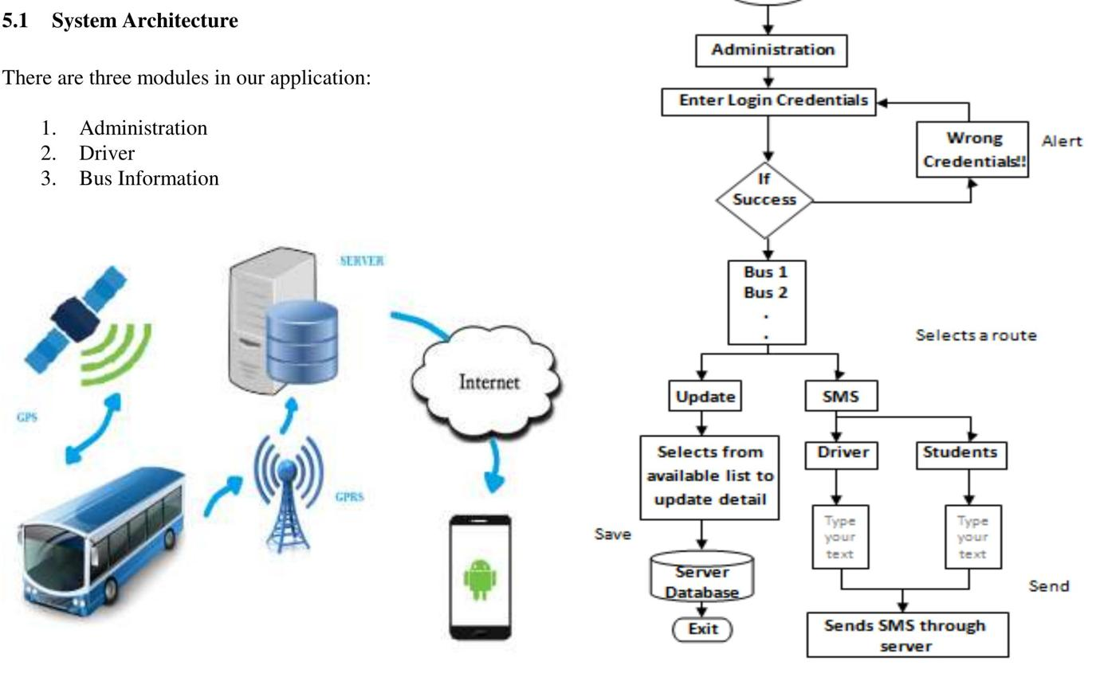
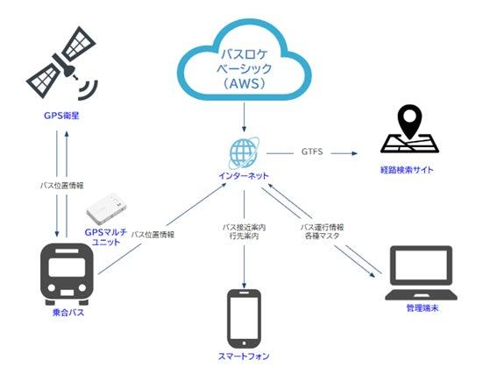
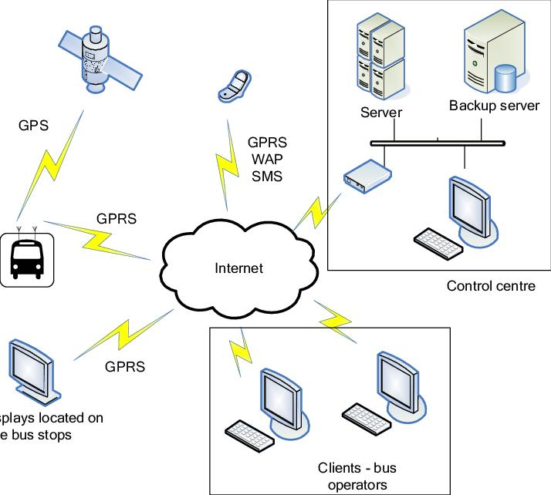
6
For an accurate diagram of your own system, use the following structure as a guide:
- Draw a large rectangle labelled Intelligent Public Transport Monitoring System.
- Place actors outside the rectangle.
- Draw use cases as ovals inside the rectangle.
- Connect each actor to the relevant use cases using lines.
Actors and connections to include:
- Passenger → View Bus Location, Check Arrival Time, Search Routes, View Occupancy.
- Bus Driver → Update Trip Status, Report Delay.
- Transport Administrator → Manage Buses, Manage Routes and Schedules, Monitor Delays.
- Transport Authority → View Reports and Analytics.
- GPS Service → Provide Location Data.
- Notification Service → Send Notifications.
You can draw this using a diagram tool such as diagrams.net.
4. Prepare the Software Requirement Specification (SRS)
An SRS document describes the requirements that the proposed software must satisfy.
Use the following structure for your report.
4.1 Introduction
The Intelligent Public Transport Monitoring System is designed to provide accurate and timely public transport information. It supports passengers by displaying bus locations and estimated arrival times and assists transport administrators in managing routes, schedules, and delays.
4.2 Problem Description
Passengers often face difficulties obtaining timely information about bus locations and arrival times. Transport administrators may also struggle to monitor multiple buses and identify service delays. These challenges can lead to longer waiting times, poor travel planning, and inefficient operations.
The proposed system addresses these issues through centralized monitoring and information sharing.
4.3 Scope of the System
The system includes:
- Real-time bus tracking using available location data.
- Estimated arrival-time calculation.
- Route and stop information.
- Passenger occupancy information.
- Bus and schedule management.
- Delay detection and notifications.
- Administrative reports and analytics.
The system does not itself guarantee traffic conditions, GPS availability, or exact arrival times. Its results depend on the accuracy and availability of the data it receives.
4.4 Functional Requirements
Include the functional requirements listed in Section 2.1, from FR1 to FR13.
Each requirement should be clear, specific, and testable.
For example:
FR3 – Bus Tracking: The system shall display the latest available location of a selected bus when valid location data is received.
FR4 – Arrival-Time Estimation: The system shall calculate and display an estimated arrival time for a selected bus stop when sufficient location and route data are available.
4.5 Non-Functional Requirements
Include the non-functional requirements listed in Section 2.2, from NFR1 to NFR10.
Where possible, make them measurable.
For example, rather than saying only that the system should be fast, specify an agreed response-time target, such as displaying a standard bus-location query within two seconds under the defined normal operating load. This is a proposed target that should be validated against project needs.
4.6 Use Case Descriptions
Include detailed descriptions of important use cases.
Use Case 1: Track a Bus
Field | Description
Use Case ID | UC01
Use Case Name | Track a Bus
Primary Actor | Passenger
Precondition | The system is accessible and bus location data is available.
Main Flow | 1. Passenger opens the application. 2. Passenger selects a bus. 3. System retrieves the latest available location. 4. System displays the bus location and the time of the last update.
Alternative Flow | If location data is unavailable, the system displays a message that the location cannot currently be retrieved.
Postcondition | The passenger receives the available location information or an appropriate status message.
Use Case 2: Check Estimated Arrival Time
Field | Description
Use Case ID | UC02
Use Case Name | Check Arrival Time
Primary Actor | Passenger
Precondition | Bus route and sufficient location data are available.
Main Flow | 1. Passenger selects a route or bus stop. 2. System identifies relevant buses. 3. System estimates arrival times. 4. System displays the estimates.
Alternative Flow | If data is insufficient, the system informs the passenger that an estimate is unavailable.
Postcondition | The passenger can view the available arrival-time estimate.
Use Case 3: Manage Bus Routes
Field | Description
Use Case ID | UC03
Use Case Name | Manage Routes
Primary Actor | Transport Administrator
Precondition | The administrator is authenticated and authorized.
Main Flow | 1. Administrator opens route management. 2. Selects a route. 3. Adds or modifies route details and stops. 4. Saves the changes. 5. System validates and stores the updated information.
Alternative Flow | If the details are invalid, the system displays an error and requests corrections.
Postcondition | Valid route information is saved and available to authorized system functions.
4.7 Data Requirements
The system should store and manage the following information:
Data Entity | Example Attributes
User | User ID, name, contact details, account role
Bus | Bus ID, registration number, capacity, operational status
Route | Route ID, route name, starting point, destination
Bus Stop | Stop ID, name, geographical location
Schedule | Schedule ID, bus ID, route ID, planned departure and arrival times
Location Record | Bus ID, latitude, longitude, timestamp
Occupancy Record | Bus ID, estimated passenger count, capacity, timestamp
Delay Record | Bus ID, route ID, delay duration, recorded time
Notification | Notification ID, message, recipient, timestamp
Operational Report | Report ID, report period, route statistics, delay statistics
Sensitive data should be protected, and the system should retain only the information necessary for its intended purpose.
4.8 External Interface Requirements
1. User Interface
- A passenger interface for bus tracking and route searches.
- An administrative dashboard for monitoring and management.
- Clear messages when location data is unavailable.
2. Hardware Interface
- GPS-enabled devices or tracking units installed in buses, where applicable.
3. Software Interface
- A database to store routes, schedules, and location records.
- A GPS or location-data service.
- A notification service, if notifications are supported.
4. Communication Interface
- A network connection for sending and receiving data.
- Secure communication protocols for sensitive information.
4.9 System Features
The major system features are:
- Real-time bus tracking.
- Estimated arrival-time calculation.
- Route and schedule management.
- Passenger occupancy monitoring.
- Delay detection and notifications.
- Administrative dashboard.
- Reports and analytics.

5. Identify Assumptions and Constraints
5.1 Assumptions
Assumptions are conditions considered likely to be true while designing the system.
- Buses are equipped with GPS-enabled devices or another supported location source.
- Location data is available at reasonable intervals.
- Passengers have access to a suitable device and network connection.
- Transport administrators maintain accurate route and schedule information.
- A method for collecting or estimating passenger occupancy is available.
- External GPS and notification services can provide the required interfaces.
5.2 Constraints
Constraints are limitations that affect the development or operation of the system.
Constraint Type | Description
Technical | GPS inaccuracies, network failures, and limited data availability.
Operational | Drivers and administrators must follow appropriate procedures to maintain accurate information.
Economic | GPS devices, servers, software development, and maintenance involve costs.
Legal | The system must comply with applicable privacy, data protection, and transport regulations.
Time | The project must be completed within the allocated academic or development schedule.

6. Validate Requirement Completeness and Consistency
Requirement validation ensures that the requirements are clear, complete, consistent, and testable.
6.1 Completeness Check
Check whether all major stakeholder needs are addressed.
- Can passengers view bus locations and arrival times?
- Can passengers search routes and view available occupancy information?
- Can administrators manage routes and schedules?
- Can the system detect delays using available data?
- Can transport authorities access operational reports?
- Are security and availability requirements included?
- Are errors and unavailable data handled appropriately?
6.2 Consistency Check
Check that requirements do not contradict each other.
For example, the system should not display an arrival time as exact when the requirement defines it as an estimate.
Similarly, only authorized administrators should be able to modify route and schedule information.
6.3 Ambiguity Check
Avoid unclear statements such as:
- "The system should be fast."
- "The system should be secure."
- "The bus location should be updated regularly."
Instead, define measurable or testable expectations.
For example:
- The system should display a standard search result within an agreed response-time target under normal operating conditions.
- Only authenticated, authorized administrators may modify route information.
- The system should display the timestamp of the latest received bus-location update.
6.4 Redundancy Check
Avoid repeating the same requirement under different IDs unless there is a clear reason.
For example, "display bus location" and "show the current location of the bus" may describe the same feature and should usually be combined.
6.5 Suggested Improvements
- Assign a unique ID to every requirement.
- Use clear and testable statements.
- Include error-handling requirements.
- Define response-time and update-frequency targets.
- Identify the source of passenger occupancy data.
- Define access permissions for each user role.
- Verify requirements with passengers and transport administrators.
- Maintain traceability between stakeholder needs, system requirements, and test cases.
Conclusion
The Scenario-Based Requirement Analysis identifies the requirements of the Intelligent Public Transport Monitoring System and documents them in an SRS. The proposed system supports bus tracking, arrival-time estimation, route management, occupancy monitoring, delay detection, and administrative reporting. A complete and validated SRS provides a foundation for designing, developing, testing, and maintaining the software.
Output:
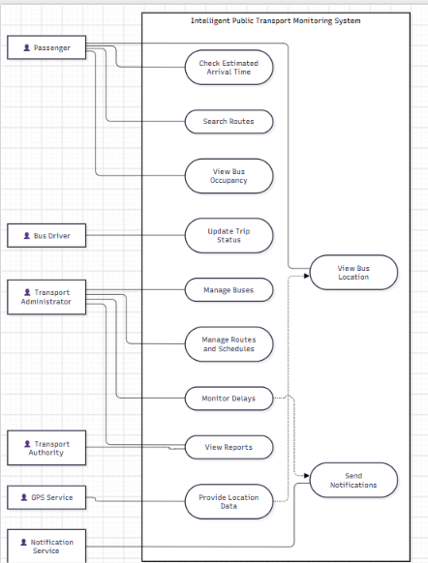

Rubrics for Calculation
Criteria | Excellent (4 Marks) | Good (3 Marks) | Satisfactory (2 Marks) | Needs Improvement (1 Mark)
Scenario Understanding and Problem Analysis (30%) | Demonstrates thorough understanding of the scenario, stakeholders, objectives, and business context with clear analysis. | Demonstrates good understanding with minor omissions. | Basic understanding with limited analysis. | Poor understanding; major aspects missing or incorrect.
Functional and Non-Functional Requirement Identification (25%) | Clearly identifies comprehensive, accurate, and well-classified functional and non-functional requirements. | Identifies most requirements with minor classification errors. | Identifies only basic requirements; several omissions. | Requirements are incomplete, inaccurate, or poorly classified.
Actor Identification and Use Case Modelling (20%) | Correctly identifies all relevant actors and use cases; use case diagram is complete, accurate, and follows UML standards. | Most actors and use cases identified; diagram has minor errors. | Limited actors/use cases identified; diagram partially correct. | Actors/use cases missing or incorrect; diagram absent or inaccurate.
Software Requirement Specification (SRS) Documentation (15%) | SRS is well-structured, complete, professionally organized, and includes all required sections. | SRS is organized with minor missing sections or formatting issues. | SRS includes only essential sections with limited detail. | SRS is incomplete, poorly organized, or lacks essential components.
Assumptions, Constraints, and Requirement Validation (10%) | Clearly identifies realistic assumptions and constraints; validates requirements for completeness, consistency, and ambiguity with appropriate justification. | Identifies most assumptions and constraints; validation is adequate. | Limited assumptions/constraints; validation is superficial. | Assumptions, constraints, and validation are missing or incorrect.

Criteria | Mark
Scenario Understanding and Problem Analysis (30%) | /5
Functional and Non-Functional Requirement Identification (25%) | /5
Actor Identification and Use Case Modelling (20%) | /5
Software Requirement Specification (SRS) Documentation (15%) | /5
Assumptions, Constraints, and Requirement Validation (10%) | /5
TOTAL | /25

